How YouTube Serves Your Content to Viewers
To understand why your videos might stop getting pushed or why they thrive, it’s essential to grasp how YouTube serves content.
Here’s a breakdown of how it works

Three Levels of Viewer Buckets
The simplest way to understand YouTube is to imagine there are the three levels of buckets it tests your content with.
- Hot
- Warm
- Cold
(If you don't know what a bucket is, watch the level 1 intro module and check out the docs “How YouTube works” from the start.

🔴 Level 1: Hot Viewer Buckets (Fans )
These are the most important viewers in the world, they build your business, they come back and support you, they become fans.
- Characteristics:
  - Come back to your content on a regular basis
  - Love your topic and channel.
  - Provide high viewer satisfaction to your videos.
  - Buy your stuff
- Outcome of new video:
  - If “Level 1 - Hot Viewers” show “high viewer satisfaction” on a new video, YouTube pushes it to more people in the Level 1 buckets with high satisfaction and tests it with more people like them.
  - If “Level 1 - Hot Viewers” show “low viewer satisfaction” on a new video, YouTube pushes it to less people in the Level 1 buckets or stops.
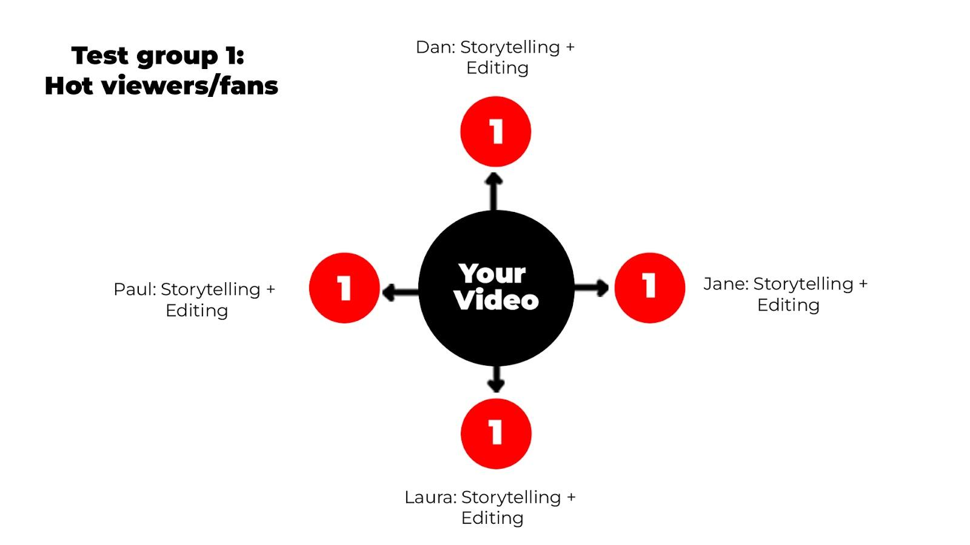

🟠 Level 2: Warm Viewers
- Characteristics:
  - Watched you before but haven’t returned recently.
  - Interested in your topic but haven’t discovered you yet.
  - Similar viewing behavior to your Level 1 - Hot Viewers.
- Outcome:
  - If “Level 2 - Warm Viewers” show “high viewer satisfaction” on a new video, YouTube pushes it to more people in the Level 2 buckets with high satisfaction and tests it with more people like them.
  - If “Level 2 - Warm Viewers” show “low viewer satisfaction” on a new video, YouTube pushes it to less people in the Level 2 buckets or stops.
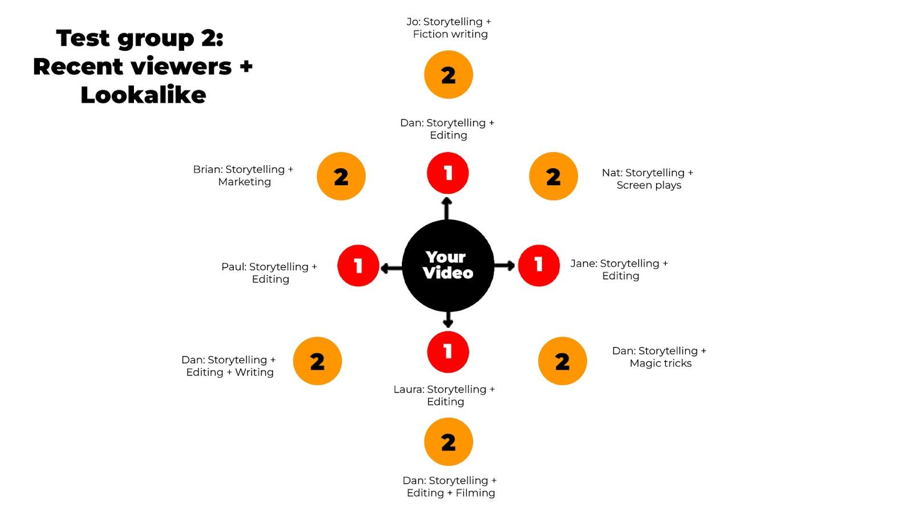

🔵 Level 3: Cold Viewers (New)

- Characteristics:
  - Never seen your channel before.
  - May have similar interests to your Hot/Warm viewers or none at all.
  - Could be totally random
- Outcome:
  - If “Level 3 - Cold Viewers” show “high viewer satisfaction” on a new video, YouTube pushes it to more people in the Level 3 buckets with high satisfaction and tests it with more people like them.
  - If “Level 3 - Cold Viewers” show “low viewer satisfaction” on a new video, YouTube pushes it to less people in the Level 3 buckets with low satisfaction or stops.
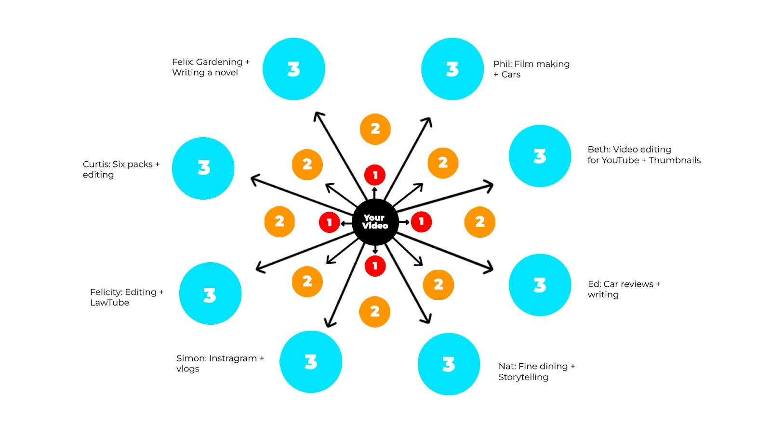

Chart: How YouTube Tests and Serves Content
Level | Viewer Type | Tested Bucket Response | Outcome
1 | Hot Viewers (Fans) | ✅ High satisfaction | Push to more Level 1- Hot buckets.
 |  | ❌ Low satisfaction | Stop pushing to disinterested buckets but continue with performing ones (If there are any)
2 | Warm Viewers | ✅ High satisfaction | Push to more warm viewer buckets.
 |  | ❌ Low satisfaction | Stop pushing to disinterested buckets but continue with performing ones (If there are any)
3 | Cold Viewers (New) | ✅ High satisfaction after initial test | Push to more cold viewer buckets (this can take weeks or months).
 |  | ❌ Low satisfaction | Stop pushing to disinterested buckets but continue with performing ones (If there are any)

Key Points to Remember
- Initial Testing: YouTube tests videos with small samples from each bucket level. Positive responses lead to broader distribution within the same level.
- Independent Buckets: Each bucket is evaluated on its own merit. Poor performance in one doesn’t stop YouTube from testing others.
- Cold Viewers Take Time: Cold buckets are the hardest to penetrate. A video might perform poorly initially but gain traction later. Expect this to take weeks to hit a cold audience. (Unless targeting a trend or a news story)
- Growth Strategy:
  - Turn Cold Viewers into Warm and eventually Hot Viewers by making consistent content targeting the top of your umbrella.
  - Build a loyal Level 1 audience (Hot Viewers) for reliable traffic and revenue.
- Small Channels: If you’re just starting, expect slow growth as you don’t have any Level 1- Fans or Level 2 - Warm viewers yet.
Success depends on breaking into Level 3 buckets over time. This won't happen fast.
How YouTube Serves Content to Viewers Simplified
YouTube tests your videos with three viewer levels:
- Hot (Fans): Loyal viewers who love your content.
  - High satisfaction: Pushed to more fans and similar viewers.
  - Low satisfaction: Stops pushing to disinterested fans but may test warm/cold viewers.
- Warm: Past viewers or potential fans interested in your topic.
  - High satisfaction: Pushed to more warm viewers.
  - Low satisfaction: Limited to warm viewers, might still test with fans.
- Cold: New viewers who’ve never seen you.
  - High satisfaction: Gradually pushed to more cold viewers.
  - Low satisfaction: Stops pushing entirely.
Key Tip: To grow, turn cold viewers into fans by making engaging content they’ll love.

